 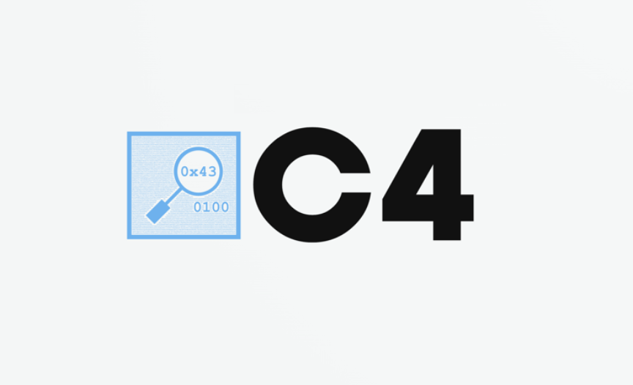 

C4-TIE Spring 2024 Hackathon

February 23-25, 2024

Center for Media Arts, Computing, & Design

Participant Name: _____________________________________________

Participant’s Date of Birth: ______________________________________

Emergency Contact: ___________________________________________

Emergency Contact Number: ____________________________________

I, the undersigned, agree to the following terms and conditions for my participation in the C4-TIE Hackathon:

**Voluntary Participation**: I acknowledge that I am voluntarily participating in the hackathon and am aware of the risks associated with attending and participating in the event.

**Release of Liability**: I hereby release the organizers (C4, TIE, Clark University) from any claims, liabilities, or lawsuits that may arise because of my participation in the hackathon.

**Safety Precautions**: I agree to follow all safety guidelines and instructions provided by the organizers, including carrying my student ID at all times.

**Intellectual Property**: I acknowledge that I retain all ownership rights to what I create during the hackathon, subject to the terms of any third-party software or APIs I may use.

**Image Release**: I grant C4 and TIE permission to capture and use photographs and/or videos I may appear in for promotional/archival purposes.

**Health and Wellbeing**: I acknowledge that I am responsible for my own well-being during the event, including any medical or dietary needs.

**Code of Conduct**: I agree to adhere to the event's Code of Conduct and understand that failure to do so may result in my removal from the event.

**Data and Privacy**: I understand that any personal data collected will be used solely for the purpose of the hackathon and will not be shared with third parties.

**Amendments:** I acknowledge that C4, TIE, and Clark University reserve the right to change these terms at any time.

By signing below, I affirm that I have read and understood the terms of this waiver and release of liability and agree to abide by them.

Participant Signature: _________________________________________

Date: _______________